

Asset Practice Questions: Science

**1. Shown here is a symbol for North direction.**



**Rahul has pasted a map in his book but it is pasted sideways. He knows that Srinagar was to the North of India. How should he draw the symbol on the map?**

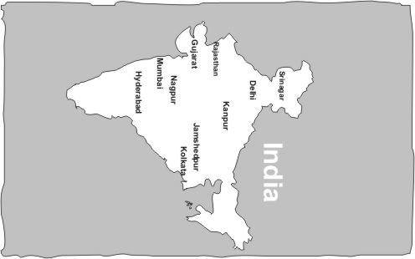

**A.  B. **

**C. D.**

**2. X, Y and Z are three wooden blocks. Z is the HEAVIEST block. When X and Y are put on a scale with a**

**10 gram weight on the other side, it looks as below.**

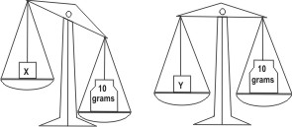

**How will the scale look when block Z is put on the scale with a 10 gram weight?**

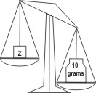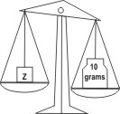**A. 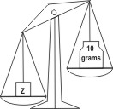 B.** 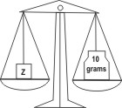

**C. D.**

**3. Shalu went to a park. There were three slides made of the same material.**

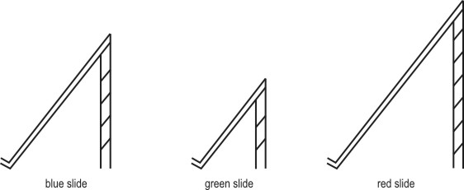

**Shalu climbs up and slides down all the slides, one after the other. On which slide will she take the MOST time to slide down?**

**A.** The red slide

**B.** The blue slide **C.** The green slide

**D.** She will take the same time on all the three slides

**4. Shown here are two types of balls. The black ball is HEAVIER than the grey ball.**



**Mansi had 4 such balls ⎯ 2 black balls and 2 grey balls.**



**Asha also had four balls. But she said that the weight of her 4 balls was more than that of Mansi's balls. Which of these could be Asha's balls?**

**A. 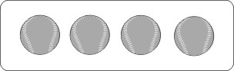 B. 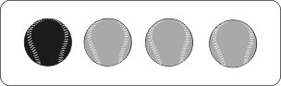 C.  D. **

**5. Rama wants to take the children of her class for mountain climbing near their city. To decide on**

**which day to take them, she looks at the weather news in the newspaper. The weather news describes**

**how the weather conditions are most likely to be. Shown below are the weather conditions from**

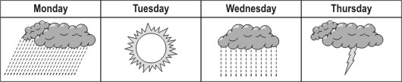**Monday to Thursday.**

**Based on this weather report, which day would be the BEST to go for mountain climbing? A.** Monday

**B.** Tuesday

**C.** Wednesday

**D.** Thursday

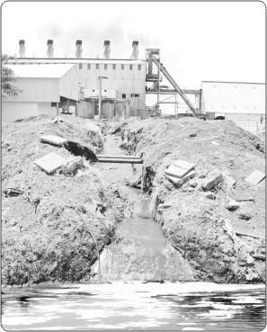

**6.**

**What is this picture showing?**

**A.** Pollution of water

**B.** Wastage of electricity

**C.** Shortage of drinking water

**D.** Construction work in a village

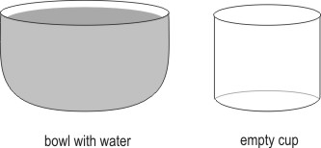**7. Shown here is a bowl full of water and an empty cup.**

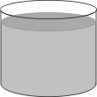**If all the water from the bowl is poured into the cup, what will it look like? A. 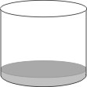 B.** 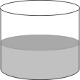

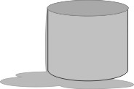

**C. D.**

**8. In Lily's village, many people use fire wood to cook their food. Lily wants her mother to use a solar cooker which cooks food using the heat of the Sun.**

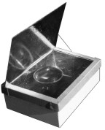

**What could be an advantage of using such a cooker? A.** It makes the food saltier.

**B.** The food will not get burnt.

**C.** Smoke will not be given out.

**D.** Cooking can be done whenever one wants.

**9. Here is a photograph of Arjun's sister. She is a 10-month-old baby and has no teeth.**



**Which of the following will she be able to eat easily? A.** Peanuts

**B.** Sugarcane pieces

**C.** Slices of raw carrot

**D.** Paste of ripe bananas

**10. Maulik had 4 different idols of Lord Ganesha, made of the following materials:**

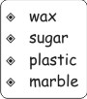  
**He kept each idol in a separate bucket of cold water and left them there for a whole night. In the morning, when he checks them, the idol made of which of these materials would have lost its shape?**

**A.** The wax one

**B.** The sugar one

**C.** The plastic one

**D.** The marble one

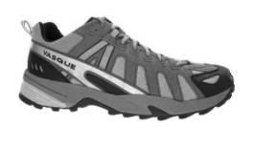**11. Maulik was wearing the following shoes and walking.**

**When he stepped on a surface, it looked like this from the side. What kind of surface was he walking on?**

**A.** A rocky park

**B.** A marble floor **C.** A sandy beach

**D.** A wooden bench

**12. There are some living creatures that spend summer in one country and winter in another country far away. Which of these could be one such living creature?**

**A. 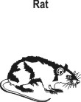 B.** 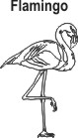

**C. 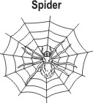 D. **